Report

Junyu Qi 22009315

**My Github URL:** [**https://github.com/JunyuQi/158258assignment2**](https://github.com/JunyuQi/158258assignment2)

**Code files, reports, and videos are all available in the Github repository, please click on the link above to access them**

1.Accessing the Website

In the WebApplication1\Views\Shared\_Layout.cshtml file, run the code and the Home page will appear.

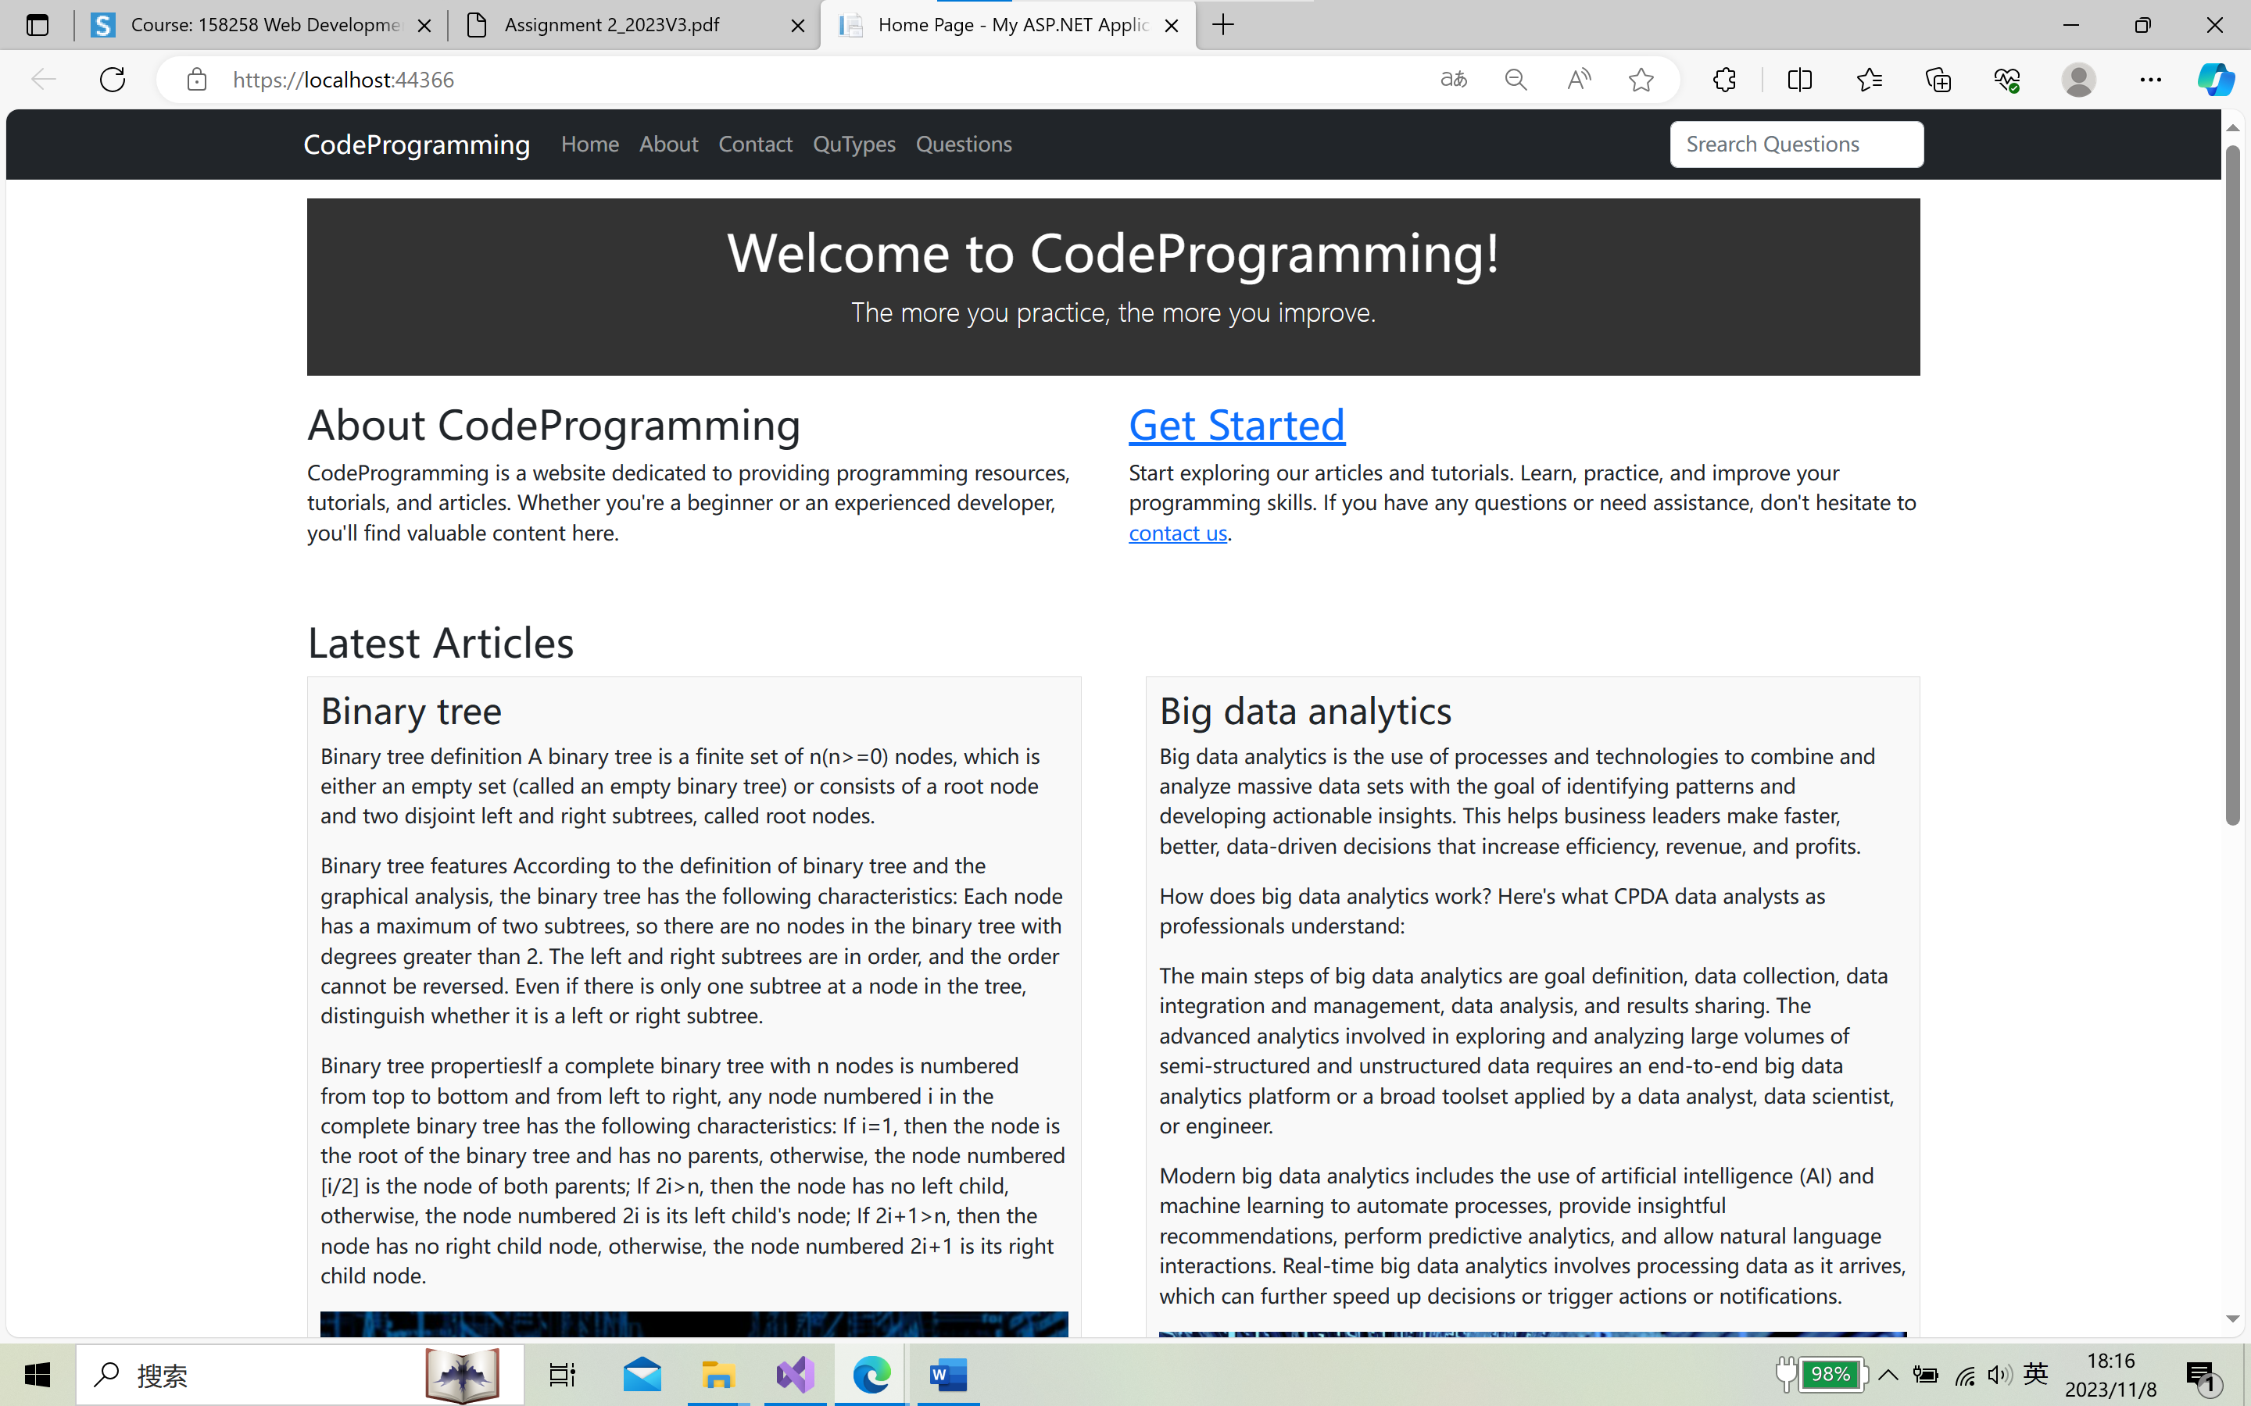

2.Website Layout

The website is designed with the following key sections:

Home Page:

The home page serves as the entry point to the website, providing an introduction to the site's purpose and content.

It includes a welcoming message and a brief overview of the website's offerings.

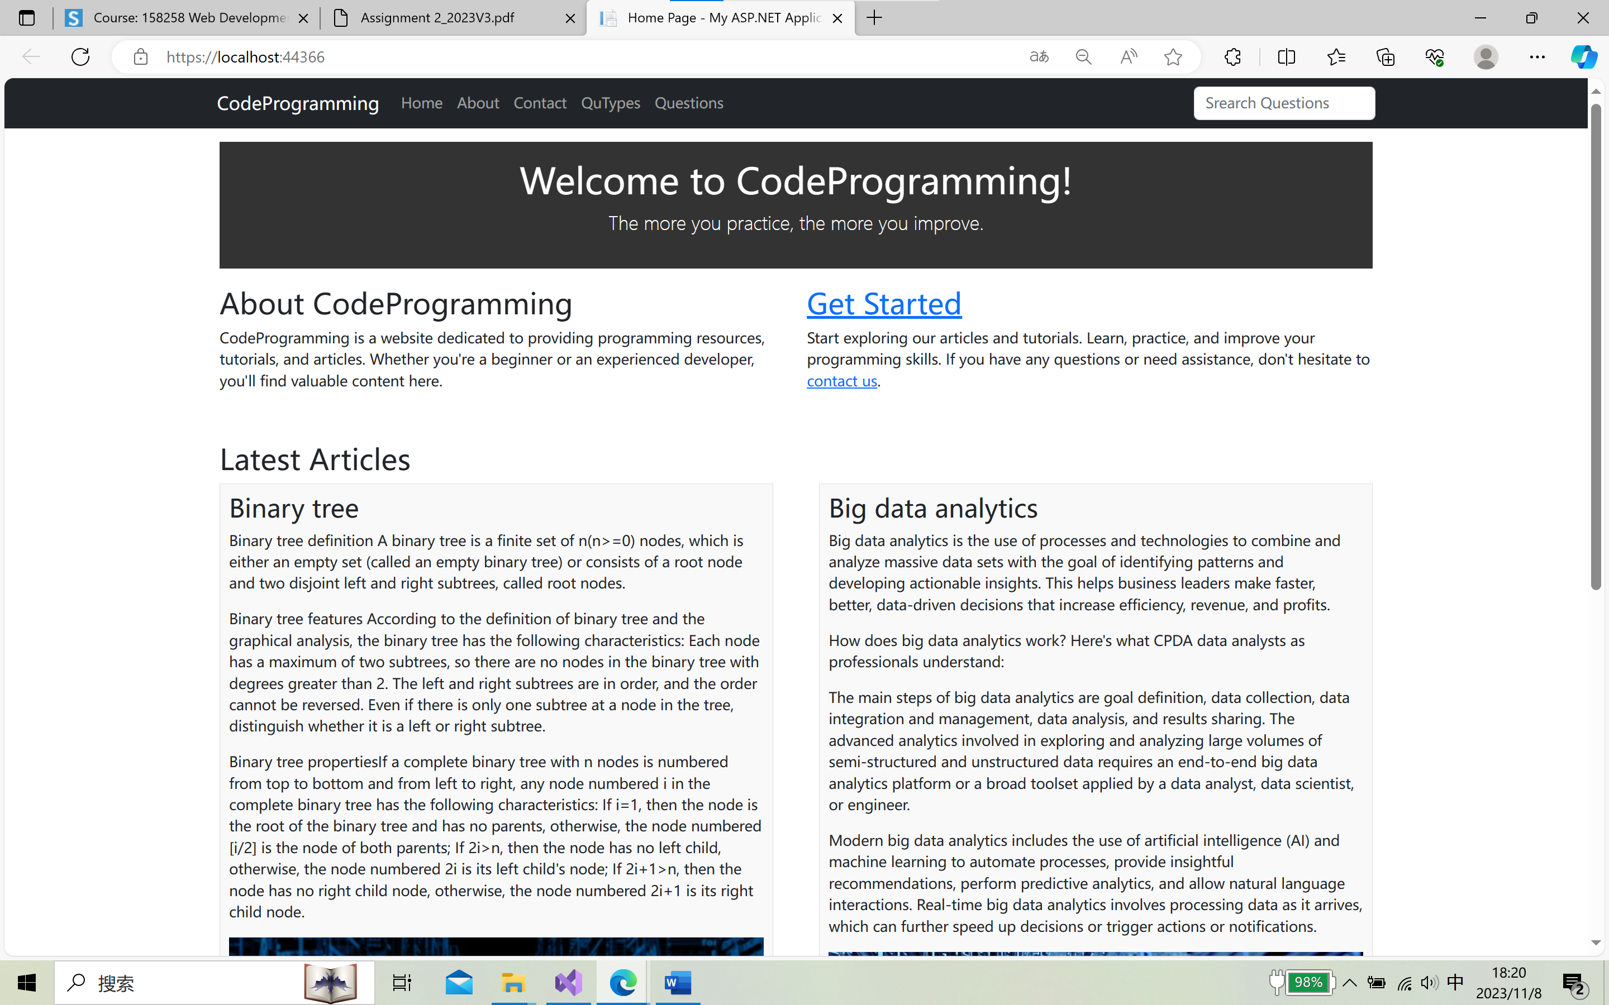

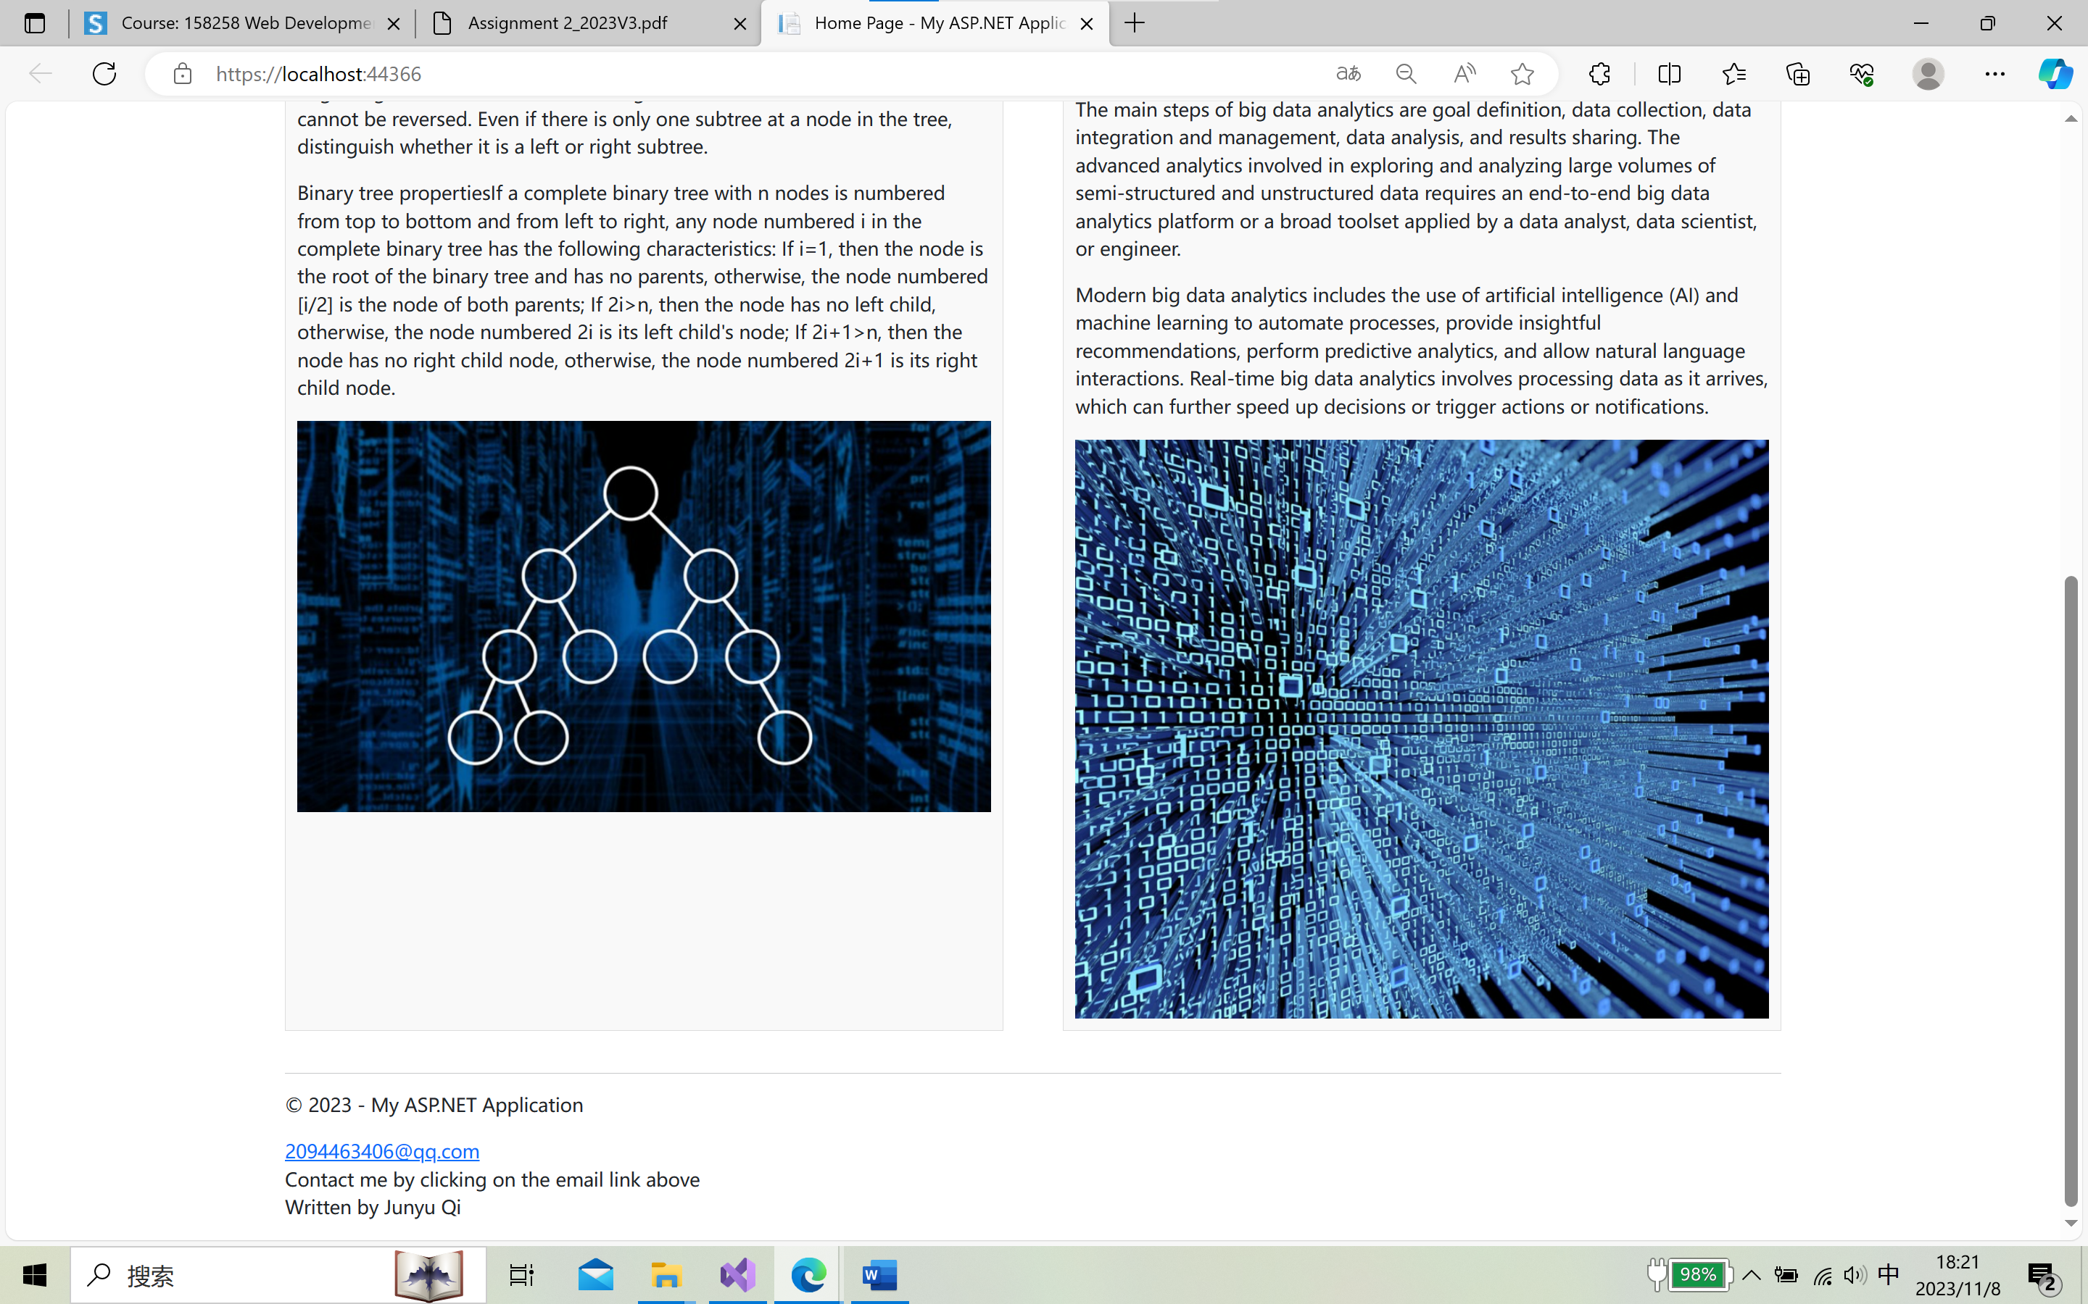

About Page:

The "About" page offers detailed information about the website, its mission, and the type of content it provides.

Users can learn more about the site's objectives and goals.

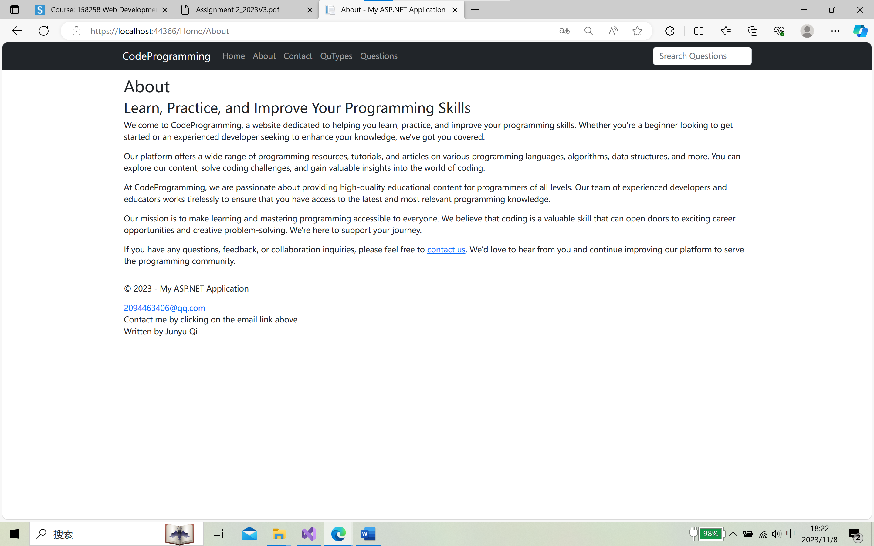

Contact Page

This page contains my contact information, which makes it easier for users to contact me, and provides a way to improve the user experience and correct errors in the future

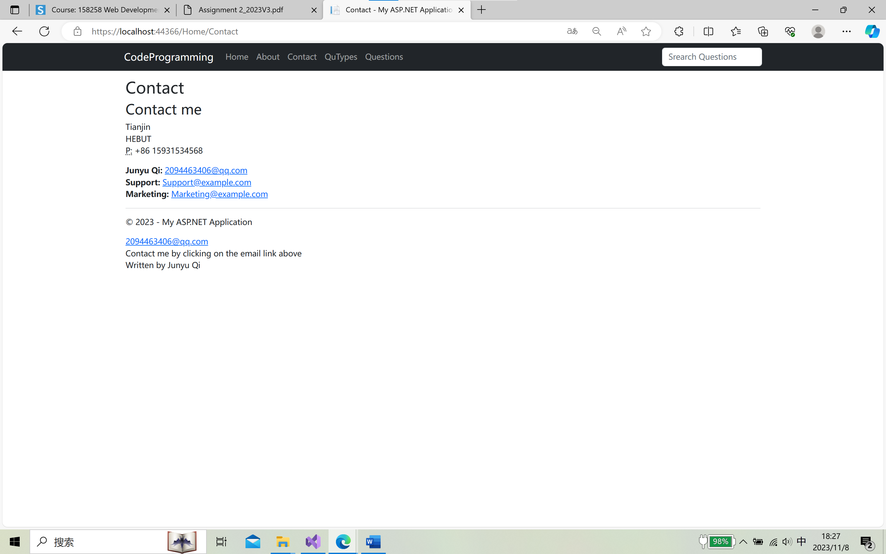

QuTypes Page:

The QuTypes page contains a category of algorithmic questions, and users can click on a category to jump to a list of all the problems in that category

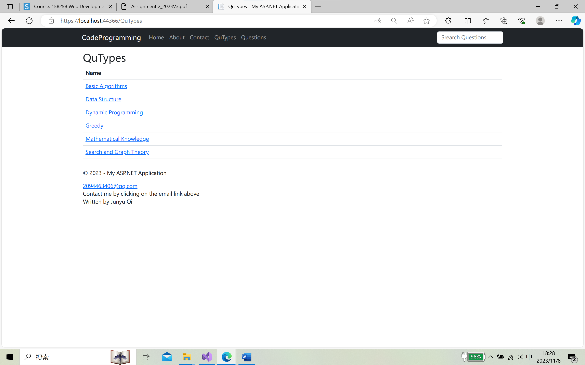

Questions Page:

The Questions page contains all the algorithm questions, and users can click on the View the original question to jump to the specific details page of the problem

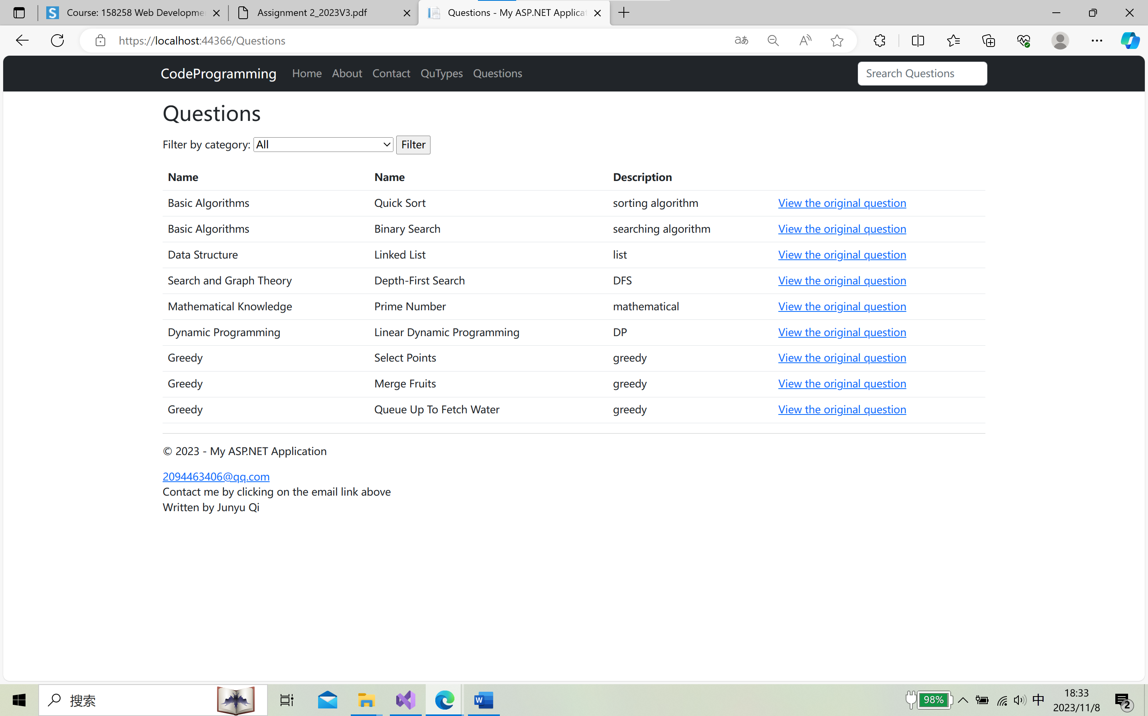

Such as Quick Sort page:

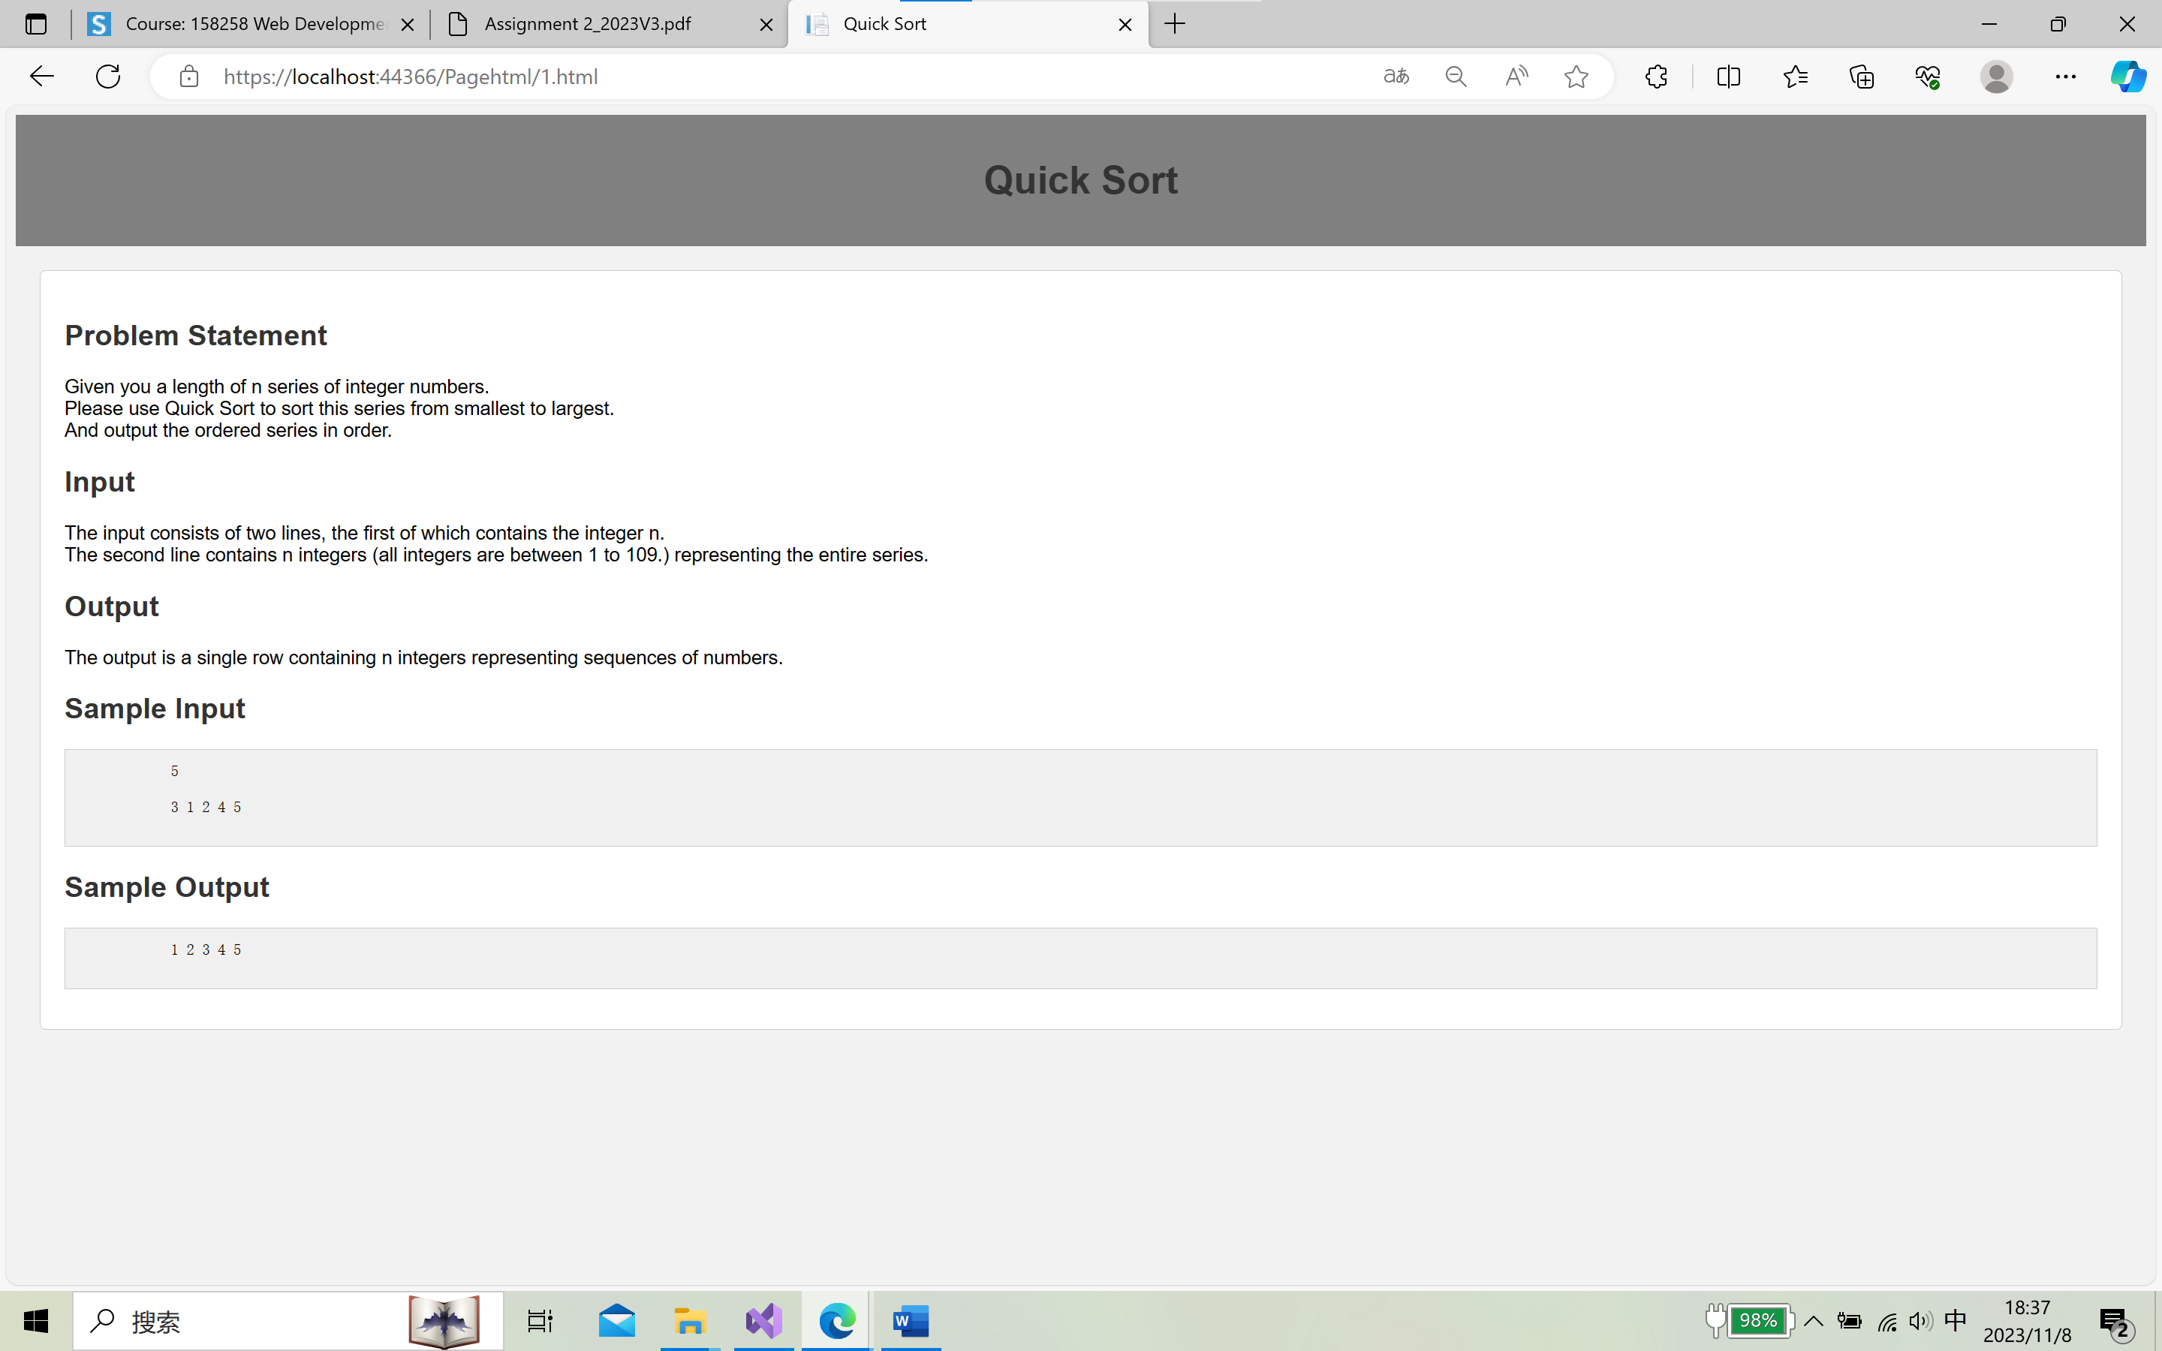

3.Utilizing Website Features:

In Home page, we can read the latest articles.

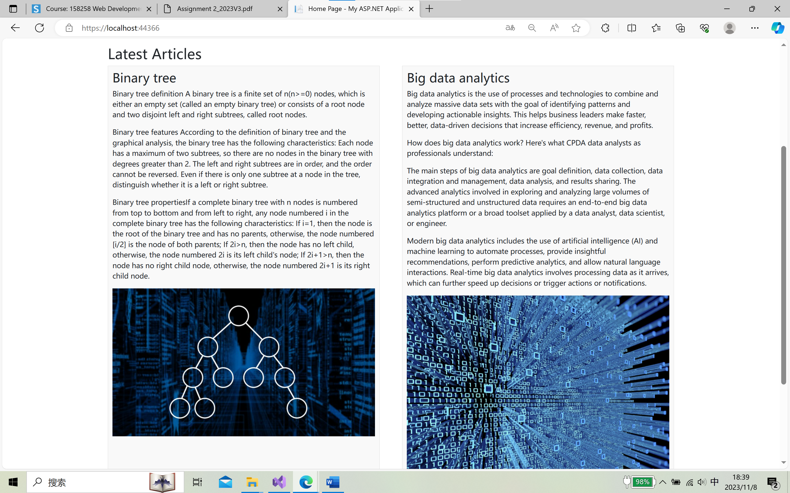

In QuTypes page, we can click on a category to jump to a list of all the problems in that category.

Such as clicking Greedy, the following page will appear:

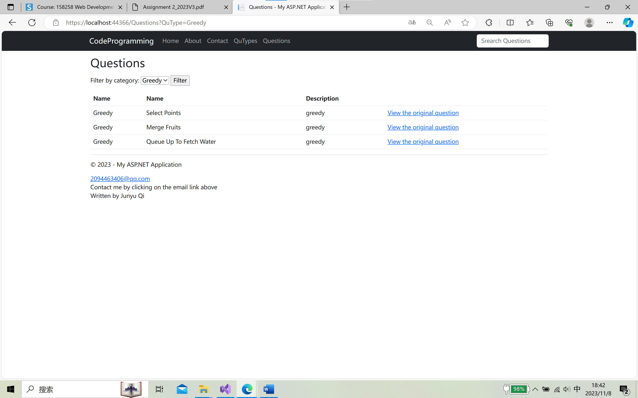

In Questions page, we can use the filter, such as choose Basic Algorithms and click on the Filter button.

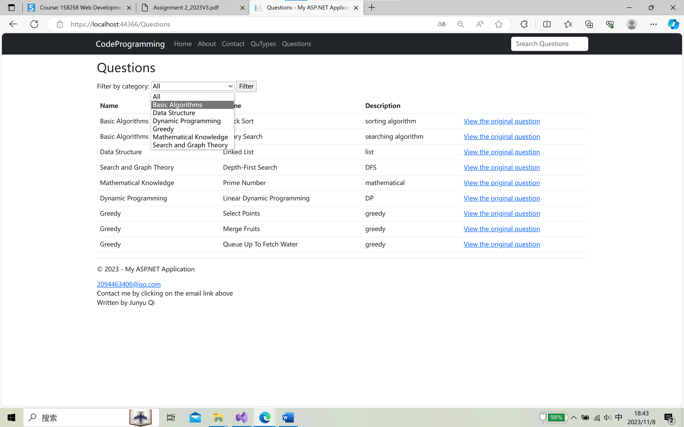

The following page will appear:

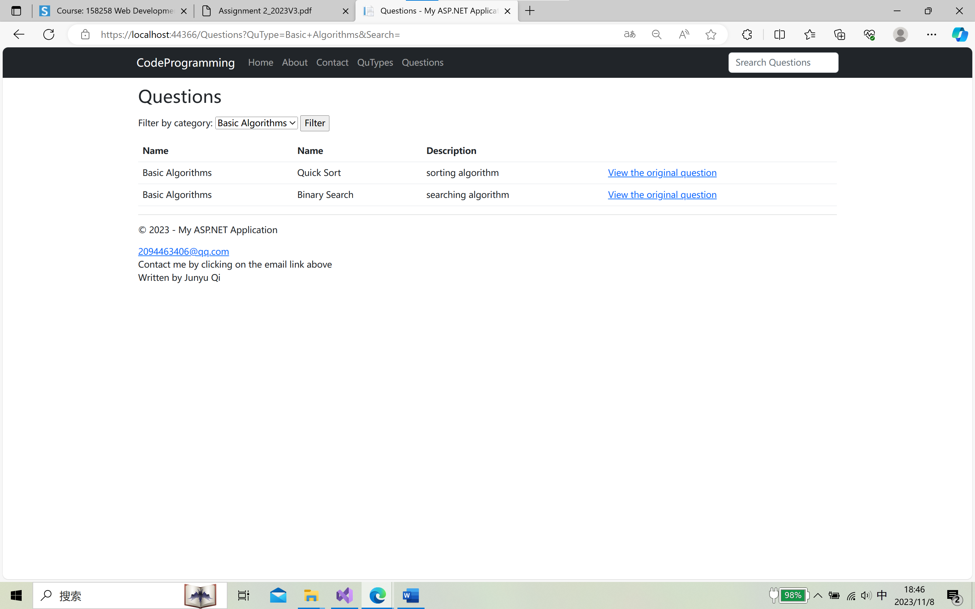

We can also search for a specific question in the search box in the top right corner of the page, for example if we type in Select Points and press enter，the following page will appear:

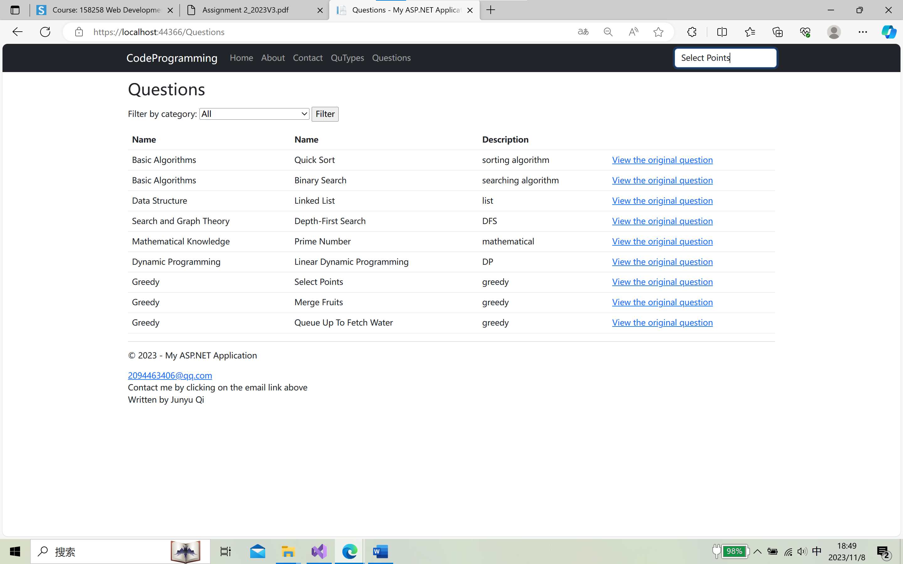

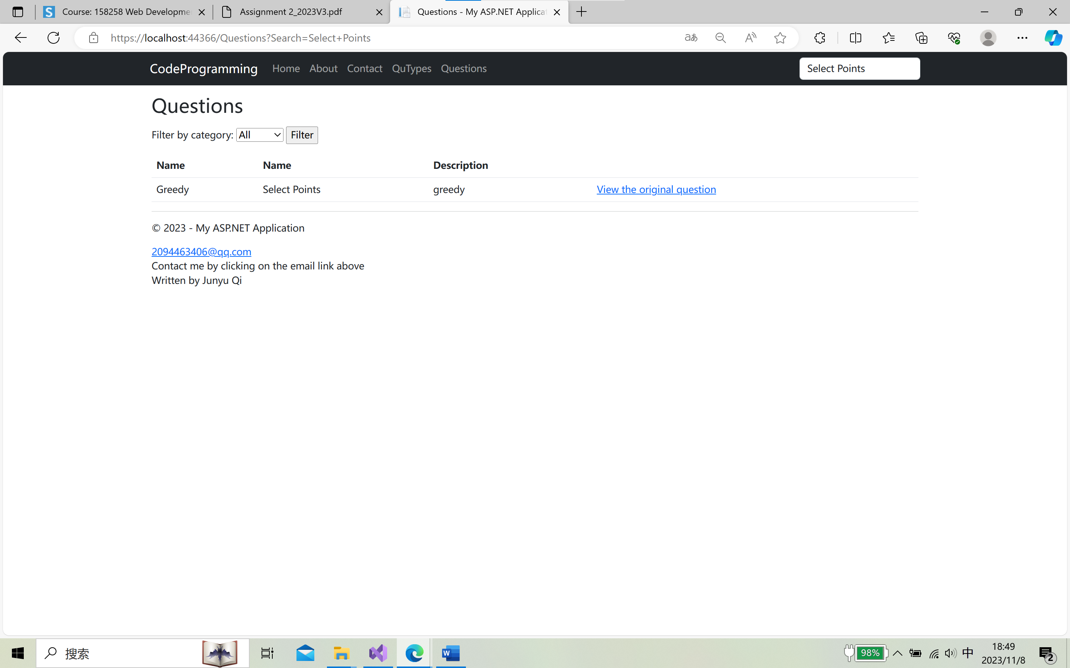

We can click on the View the original question to look at the question.

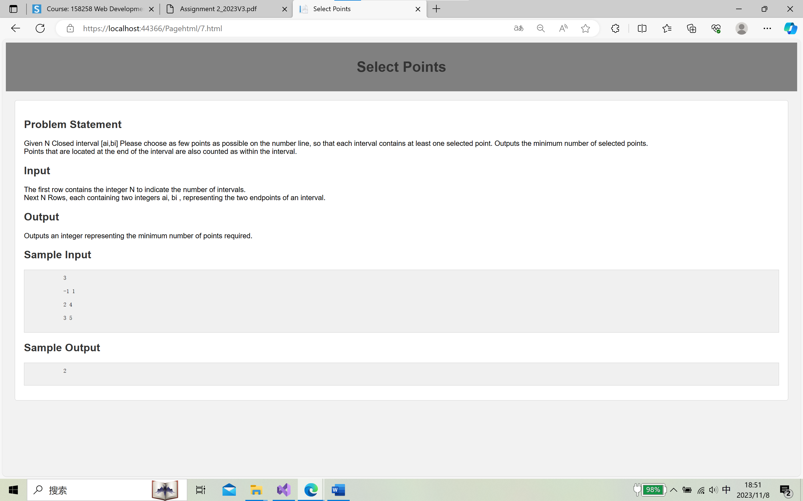

4.Technical Demonstrations:

Models:

I create two models, QuType.cs and Question.cs

QuType.cs contains the category of questions. Question.cs contains the specific question.

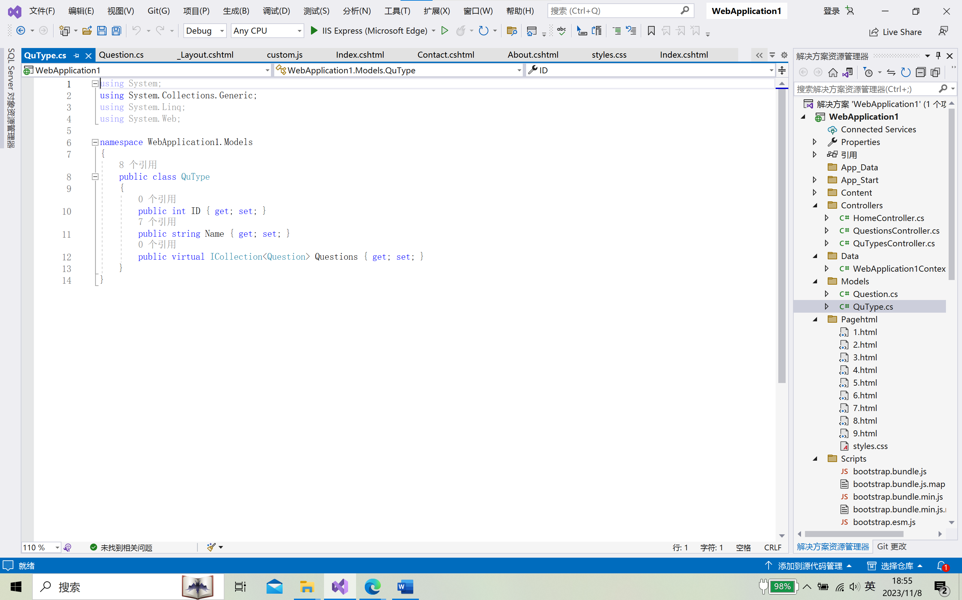

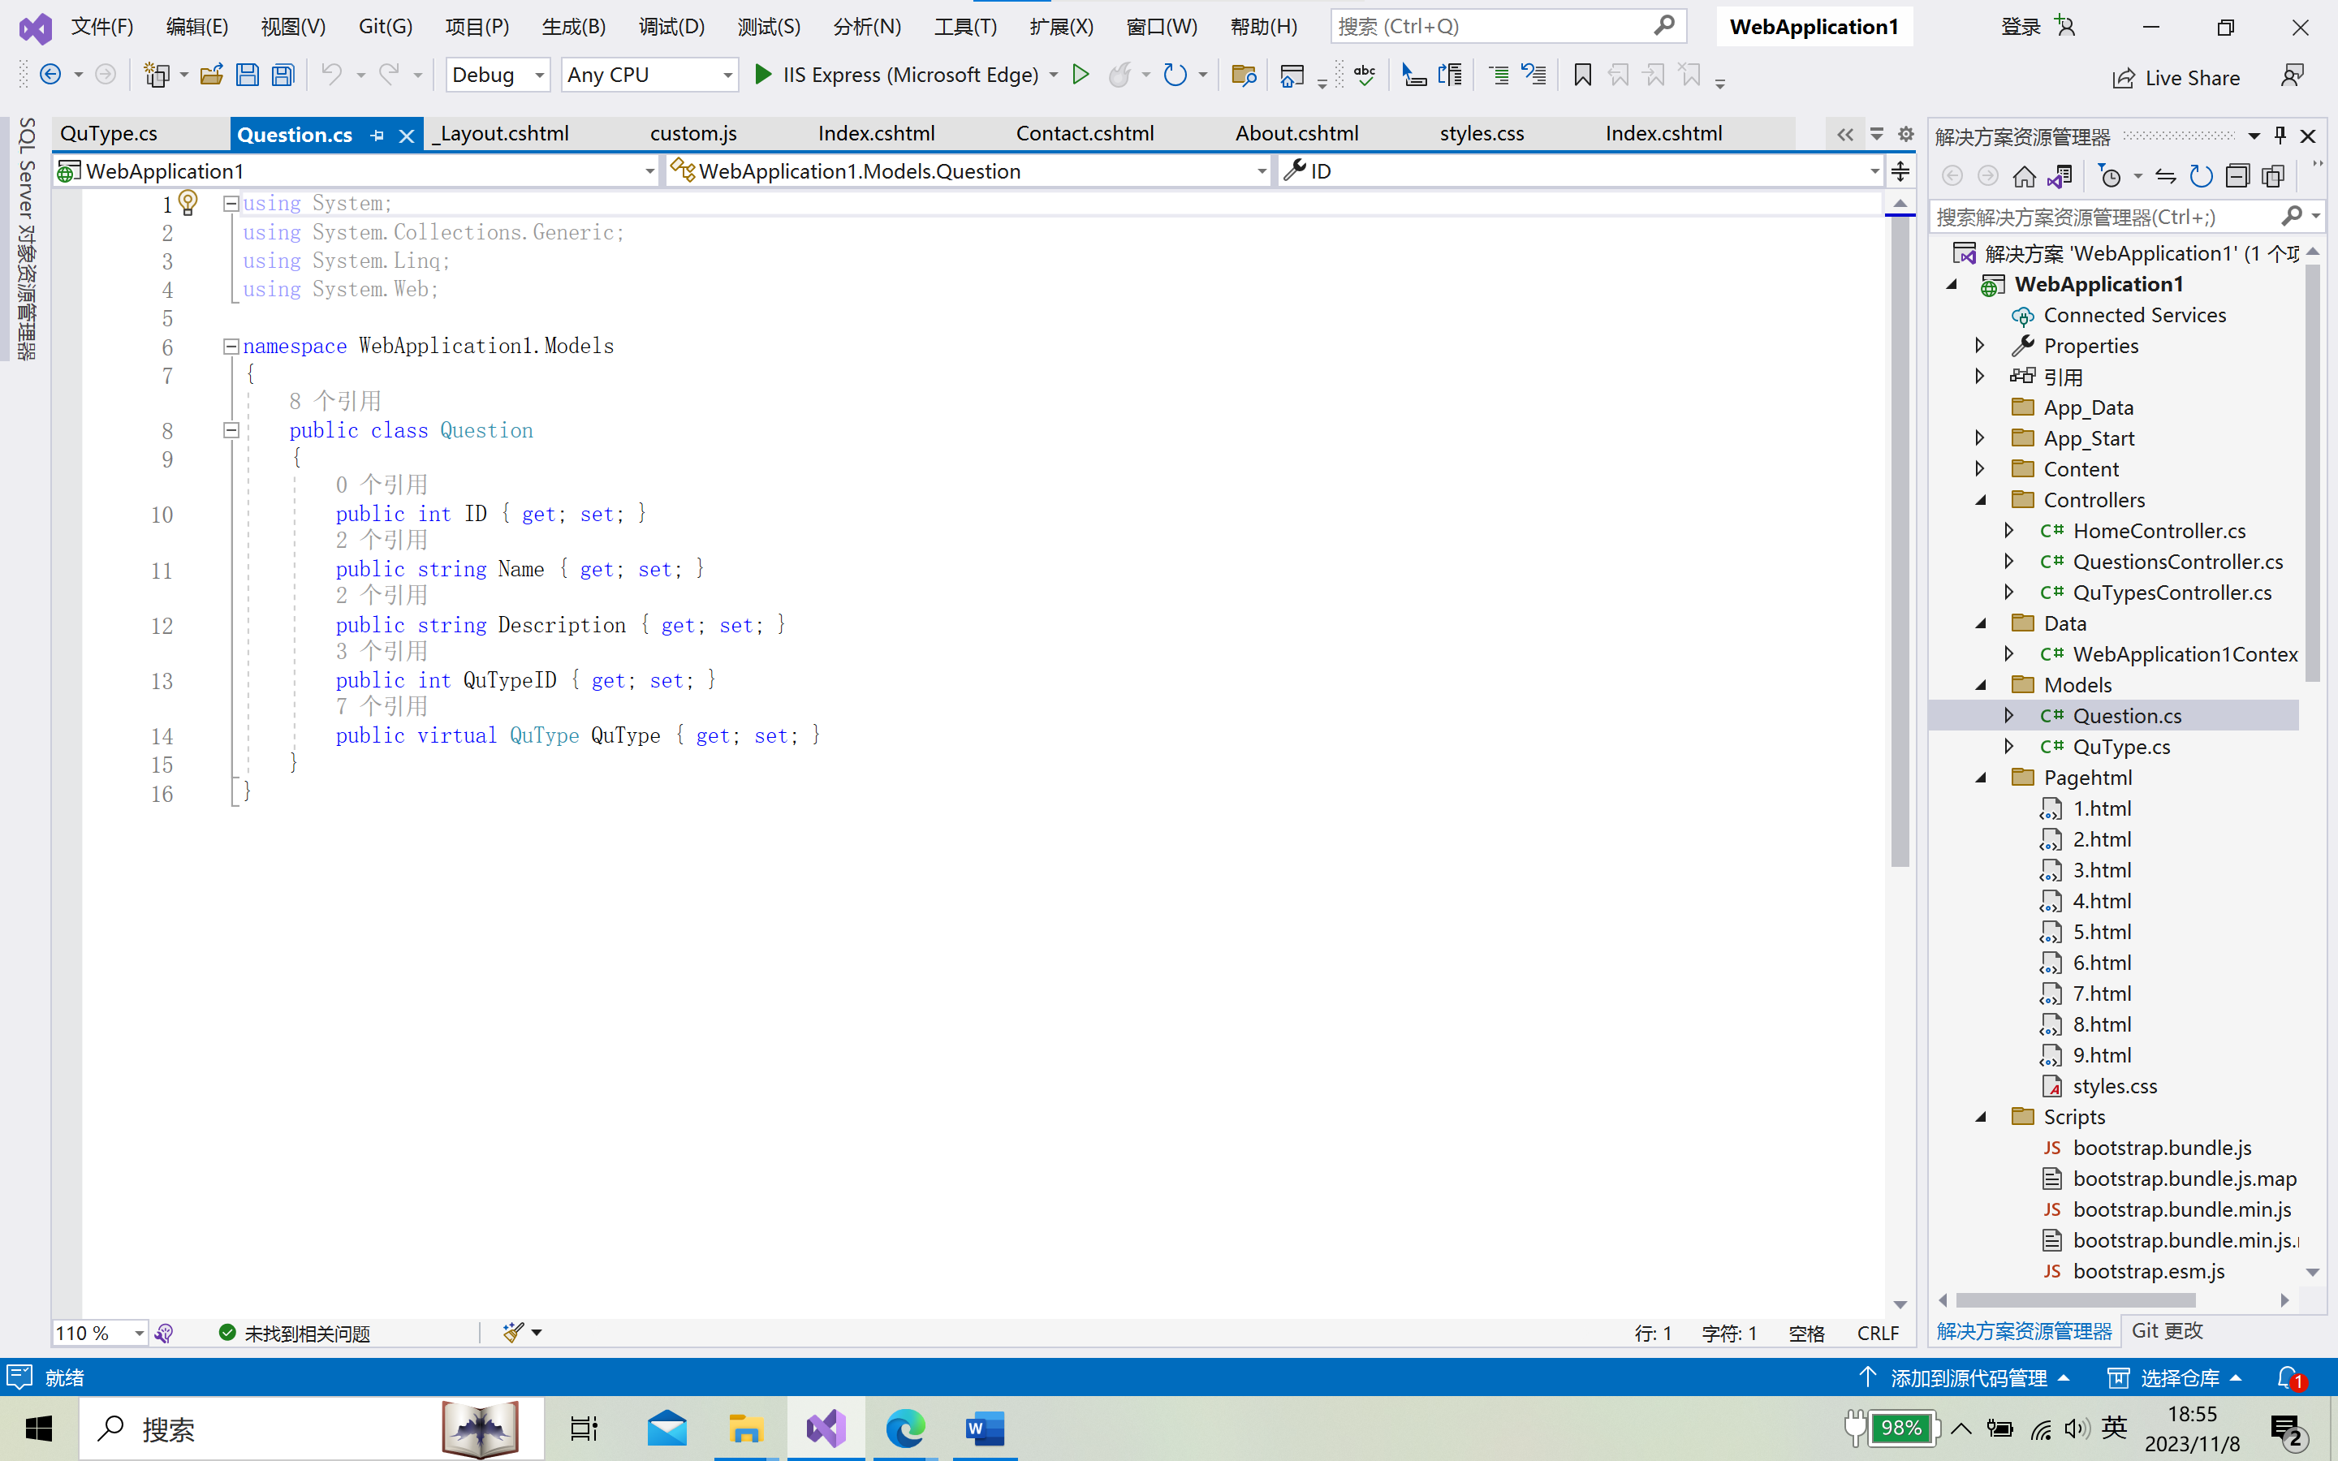

CSS:

mystyle1.css

.jumbotron: This style defines the appearance of a prominent section on your webpage. It sets the background color to a dark gray, text color to white, and adds padding and center alignment to the content within it.

.row and .col-md-6: These styles control the spacing and layout of content in a row. They add margins to create spacing between rows and columns, making the content more visually appealing.

.additional-content: This style adds spacing to content sections, creating separation from other elements on the page.

.article-list and .article: These styles manage the layout of articles on your page. They use flexbox to arrange articles side by side, and each article has a light gray background, a border, and padding. It also specifies that images within articles should be responsive, fitting the container width while maintaining their aspect ratio.

styles.css

The choice of fonts (Arial, sans-serif) for text.

Background colors for the overall page, header, and content sections.

Styling for the header, making it gray with white text, centered alignment, and padding.

Styling for the content section with a white background, padding, and a subtle border.

Text color settings for h1 and h2 headings.

Styling for code blocks (pre) with a light gray background, padding, and a border.

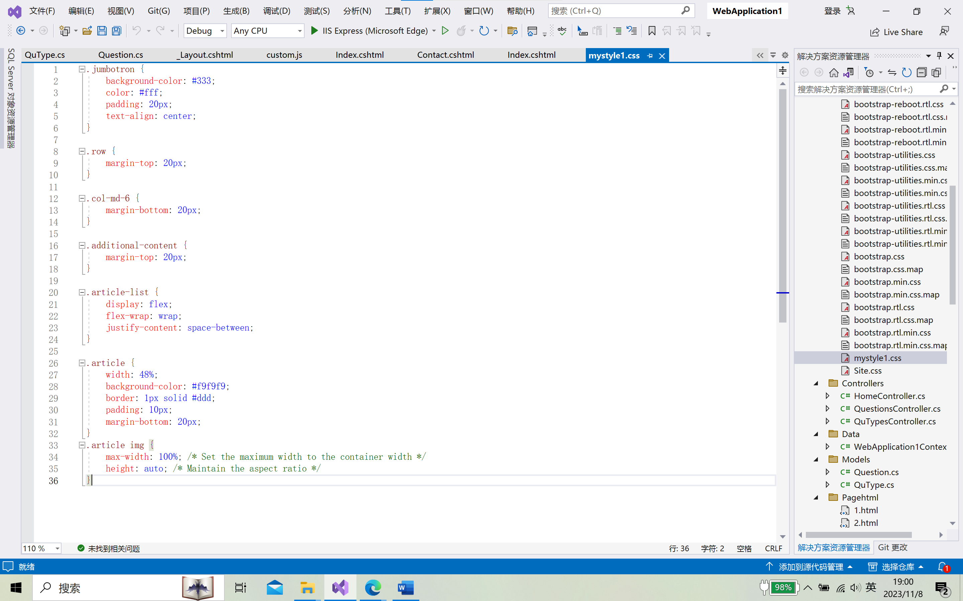

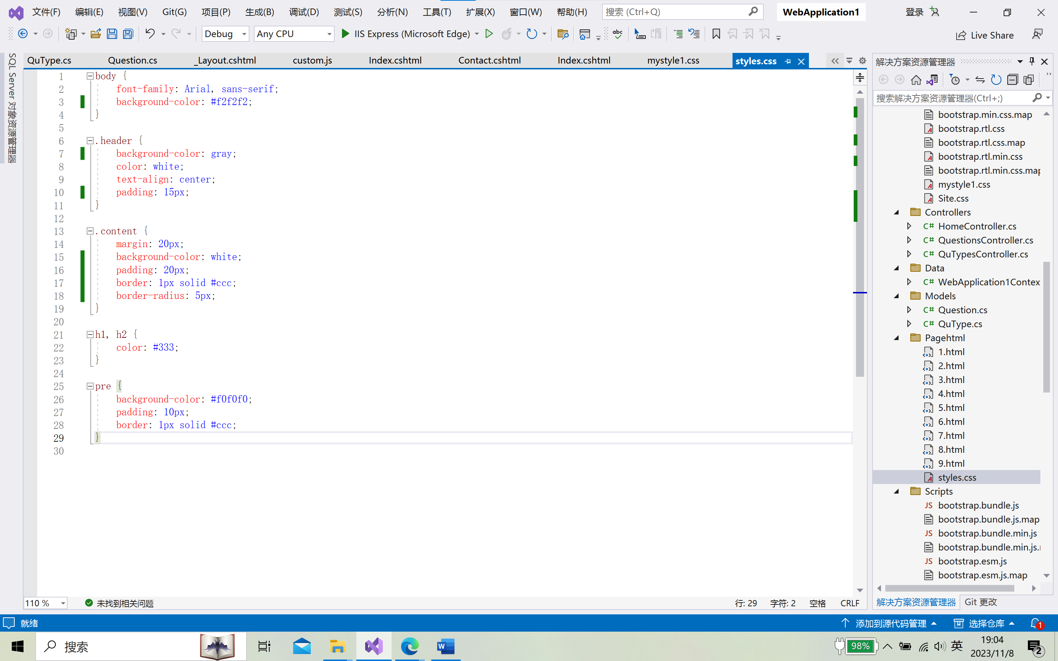

JavaScript:

custom.js

The JavaScript function redirectToHtml(id) serves the following purpose:

This function is designed to facilitate the redirection of a website user to a specific HTML page based on the provided id. It takes an id as a parameter, which represents a unique identifier associated with a particular HTML page.

The htmlUrl variable is constructed by combining the base URL"https://localhost:44366/Pagehtml/" with the id. This results in a dynamically generated URL that points to a specific HTML page. The id variable allows for the selection of the desired HTML page.

Subsequently, the window.location.href property is used to initiate the redirection. When the function is called with a valid id, the user's browser is directed to the URL constructed in the previous step.

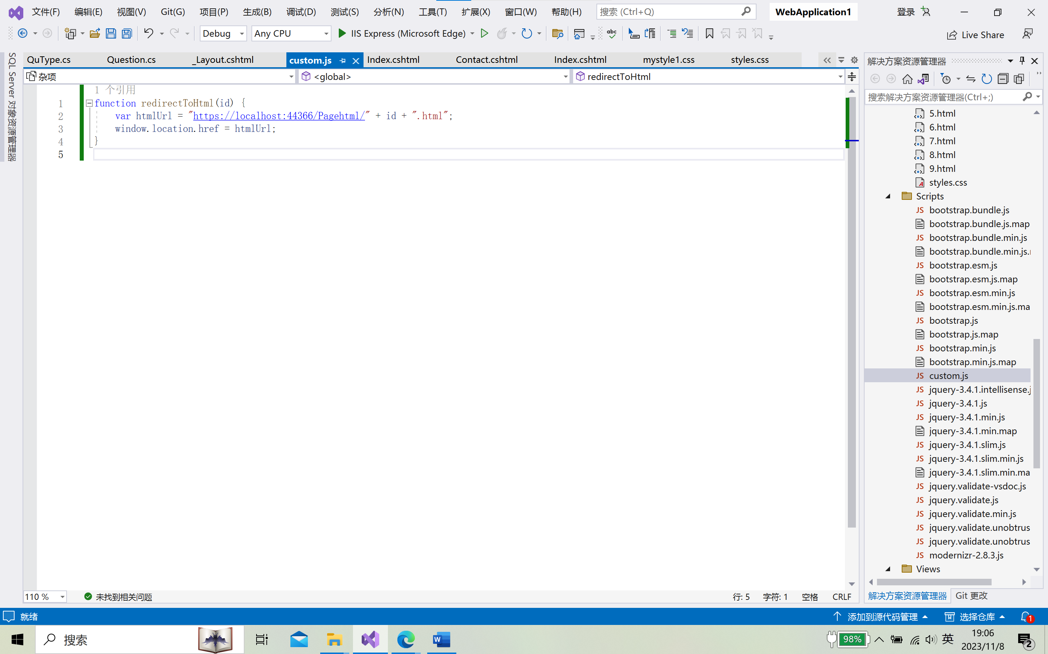

4. Feature Implementation:

Sorting QuTypes Alphabetically:

In QuTypesController Index()

public ActionResult Index()

{

return View(db.QuTypes.OrderBy(c => c.Name).ToList());

}

Filtering the Search Results by QuType Using ViewBag:

Updating the QuestionsController Index Method to Filter by QuType

Adding the Filter to the Questions Index Page:

View\ Questions\Index.cshtm

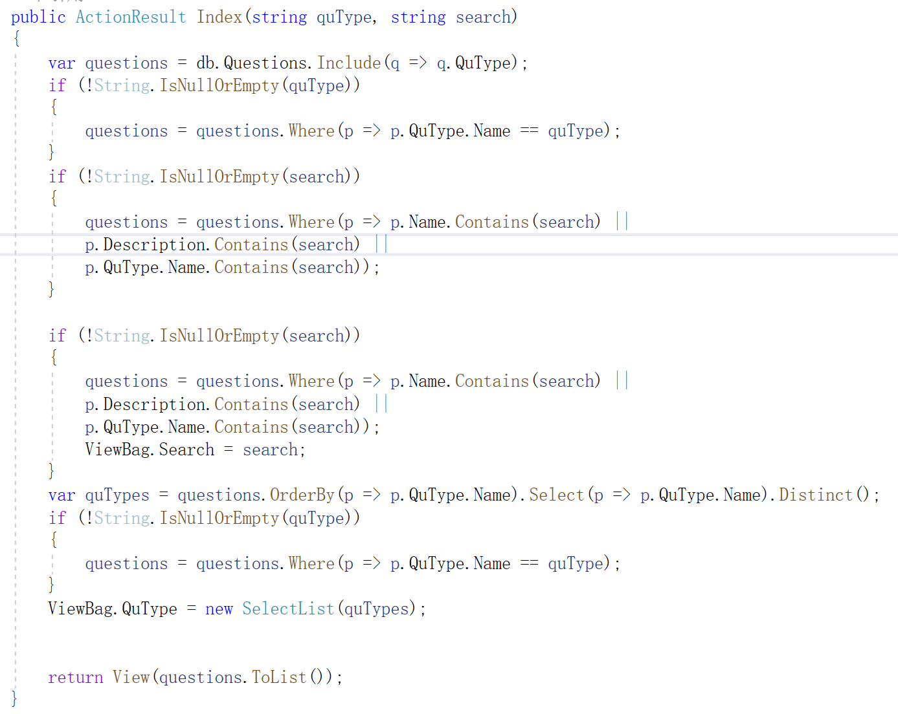

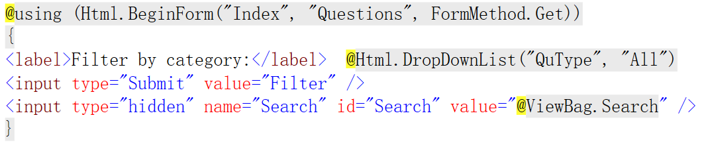

Adding a Search Box to the Main Site Navigation Bar:

_Layout.cshtml:

